Shorelume Tech Website Content

About Us
Welcome to Shorelume Tech
At Shorelume Tech, we are shaping the future of learning through innovation, technology, and practical education. As a modern educational platform, our mission is to equip students and aspiring professionals with industry-relevant skills that prepare them for the rapidly evolving digital world.
We specialize in next-generation technologies and provide hands-on training programs designed to bridge the gap between theoretical knowledge and real-world application. Our learning ecosystem empowers students to build confidence, gain practical experience, and become job-ready professionals.
Our Vision
Our vision is to create a future where quality technology education is accessible to everyone. We aim to inspire and empower the next generation of innovators, developers, designers, and tech leaders by providing modern, skill-oriented learning opportunities.
What We Offer
At Shorelume Tech, we provide professional training in some of the most in-demand and future-focused domains, including:
- Artificial Intelligence (AI)
- Data Science & Analytics
- Machine Learning
- Full Stack Web Development
- UI/UX Design
- Cyber Security
- Software Development
- Software Testing
- Cloud & Emerging Technologies
Our courses are designed with a practical approach, helping learners understand how technologies are applied in real industry environments.
Industry-Focused Learning
We believe education should go beyond theory. Our programs focus on real-world projects, practical implementation, problem-solving, and industry-standard tools so students can develop skills that employers truly value.
Innovation-Driven Education
Technology is evolving every day, and so are we. Shorelume Tech continuously updates its learning methods, course content, and training strategies to ensure students stay aligned with the latest industry trends and advancements.
Empowering Future Careers
Our goal is not just to teach skills, but to help learners build successful careers in technology. Whether someone is a beginner starting their journey or a professional upgrading their expertise, Shorelume Tech provides the guidance, mentorship, and support needed for growth.
Community & Growth
At Shorelume Tech, learning is collaborative and growth-oriented. We encourage creativity, teamwork, innovation, and continuous learning through an engaging and supportive community environment.
Why Choose Shorelume Tech?
- Industry-relevant courses
- Practical and project-based learning
- Experienced mentors and trainers
- Flexible online learning environment
- Career-focused training programs
- Continuous support and guidance
Thank You
Thank you for being a part of Shorelume Tech. Together, let’s learn, innovate, and build the future with technology.

Contact Us
Get in Touch
We’d love to hear from you! Whether you have questions about courses, need technical support, or want to share feedback, our team is here to help.
Contact Information
Email:shorelumetech@gmail.com
Phone: +91 9811308982
Website: www.shorelumetech.com
Office Hours
Monday – Friday: 9:00 AM – 6:00 PM
Saturday: 10:00 AM – 4:00 PM
Sunday: Closed
Address
Sec 17,noida
Follow Us
- Facebook
- Instagram
- LinkedIn
- Twitter/X
Contact Form
Full Name
Email Address
Subject
Message
[Send Message]

Privacy Policy
Privacy Policy for Shorelume Tech
At Shorelume Tech, we value your privacy and are committed to protecting your personal information.
Information We Collect
We may collect:
- Name and contact details
- Course progress and learning activity
- Device and browser information
How We Use Your Information
We use your information to:
- Provide and improve our services
- Personalize your learning experience
- Process payments and enrollments
- Send important updates and notifications
- Improve customer support
Data Protection
We implement appropriate security measures to protect your personal data from unauthorized access, disclosure, or misuse.
Third-Party Services
We may use trusted third-party services for payment processing, analytics, and communication tools.
Cookies
Shorelume Tech uses cookies to enhance user experience and analyze website traffic.
Your Rights
You may request access, correction, or deletion of your personal data at any time.
Contact
If you have any privacy-related questions, contact us at privacy@shorelumetech.com.

Terms & Conditions
Terms and Conditions
Welcome to Shorelume Tech. By accessing or using our platform, you agree to comply with the following terms and conditions.
User Accounts
Users are responsible for maintaining the confidentiality of their account credentials.
Course Access
Purchased courses are intended for personal use only and may not be shared or redistributed.
Payments
All payments must be completed before accessing paid content.
Intellectual Property
All content on Shorelume Tech, including videos, text, graphics, and materials, is the intellectual property of Shorelume Tech.
Prohibited Activities
Users must not:
- Share account credentials
- Upload harmful or illegal content
- Attempt unauthorized access to the platform
- Copy or distribute course materials without permission
Limitation of Liability
Shorelume Tech is not responsible for indirect damages resulting from platform usage.
Updates to Terms
We may update these terms periodically. Continued use of the platform indicates acceptance of updated terms.

FAQs & Help
Frequently Asked Questions
1. How do I enroll in a course?
Simply create an account, browse available courses, and click the enroll button.
2. Are the courses self-paced?
Yes, most courses are self-paced so you can learn according to your schedule.
3. Will I receive a certificate?
Yes, certificates are provided upon successful course completion.
4. Can I access courses on mobile devices?
Yes, Shorelume Tech is accessible on desktops, tablets, and smartphones.
5. What payment methods are accepted?
We accept major credit/debit cards and selected online payment methods.
6. How can I contact support?
You can contact our support team through email or the Contact Us page.
7. Can I request a refund?
Refund policies may vary depending on the course. Please review the course details for refund eligibility.

Quick Links
- About Us
- Contact Us
- Privacy Policy
- Terms & Conditions
- FAQs & Help

Footer Content
© 2026 Shorelume Tech. All Rights Reserved.
Empowering the next generation through technology-focused education and industry-ready skills.
Quick Links: About Us | Contact Us | Privacy Policy | Terms & Conditions | FAQs & Help

Our team section:
Founder
Jyoti Pandit
The Founder of Shorelume Tech is a visionary leader passionate about transforming education through technology and innovation. With a strong commitment to empowering students and aspiring professionals, the founder established Shorelume Tech with the mission of making next-generation technology education practical, accessible, and career-focused.
Driven by the belief that skills are the foundation of future success, the founder continues to inspire learners by creating opportunities in emerging fields such as Artificial Intelligence, Data Science, Web Development, Cyber Security, Machine Learning, and Software Development.
Through leadership, innovation, and dedication, the founder aims to bridge the gap between education and industry requirements, helping students build successful careers in the digital era.

Co-Founder
Sahil pandit
The Co-Founder of Shorelume Tech plays a vital role in shaping the organization’s growth, strategy, and learning ecosystem. Focused on innovation and student success, the co-founder is dedicated to building a platform where learners can gain practical knowledge and industry-ready skills.
With a passion for technology and education, the co-founder works closely with mentors, trainers, and development teams to ensure high-quality learning experiences and continuous improvement across all programs.
The vision is to create a dynamic and supportive environment where students can learn, innovate, and confidently achieve their career goals.

Managing Director
Harsh Ranjan singh
The Managing Director of Shorelume Tech oversees the organization’s operations, strategic planning, and long-term development. With strong leadership and a future-oriented mindset, the Managing Director ensures that the platform maintains excellence in education, innovation, and learner satisfaction.
By focusing on operational efficiency, quality training standards, and industry collaboration, the Managing Director helps Shorelume Tech grow as a trusted educational and technology platform.
The commitment is to deliver impactful learning experiences that prepare students for real-world challenges and future career opportunities.

Marketing Director
Pyush Abhijit singh
The Marketing Director at Shorelume Tech leads branding, digital outreach, and student engagement strategies. With expertise in modern marketing and communication, the Marketing Director is responsible for building the platform’s presence and connecting learners with valuable educational opportunities.
By understanding market trends and student needs, the Marketing Director helps promote innovative learning programs and strengthens the Shorelume Tech community through effective campaigns, collaborations, and digital initiatives.
The goal is to inspire more learners to explore technology-driven careers and become part of the future of innovation.

website open hote hi first interface me:
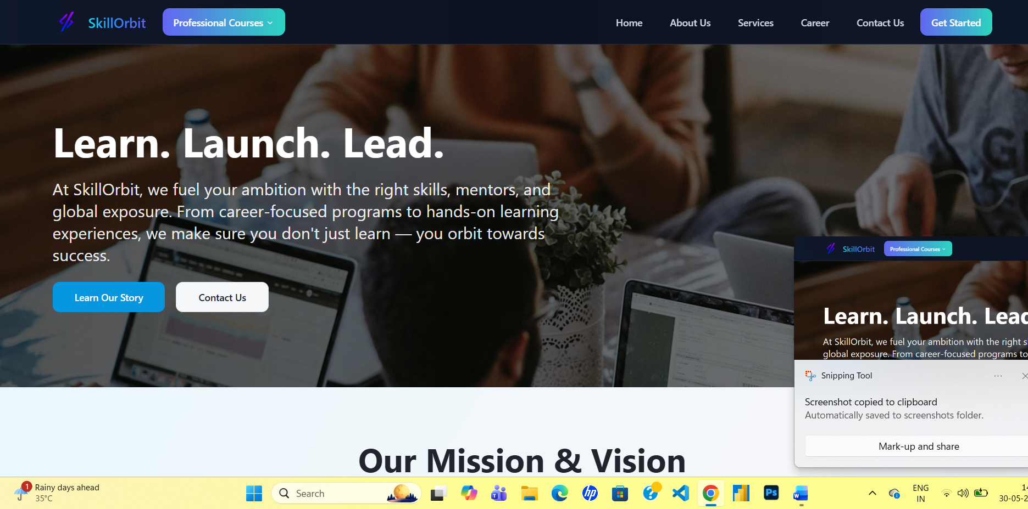

Important
Visit career section of skill orbit and take refrence

https://skill-orbit.co.in/career

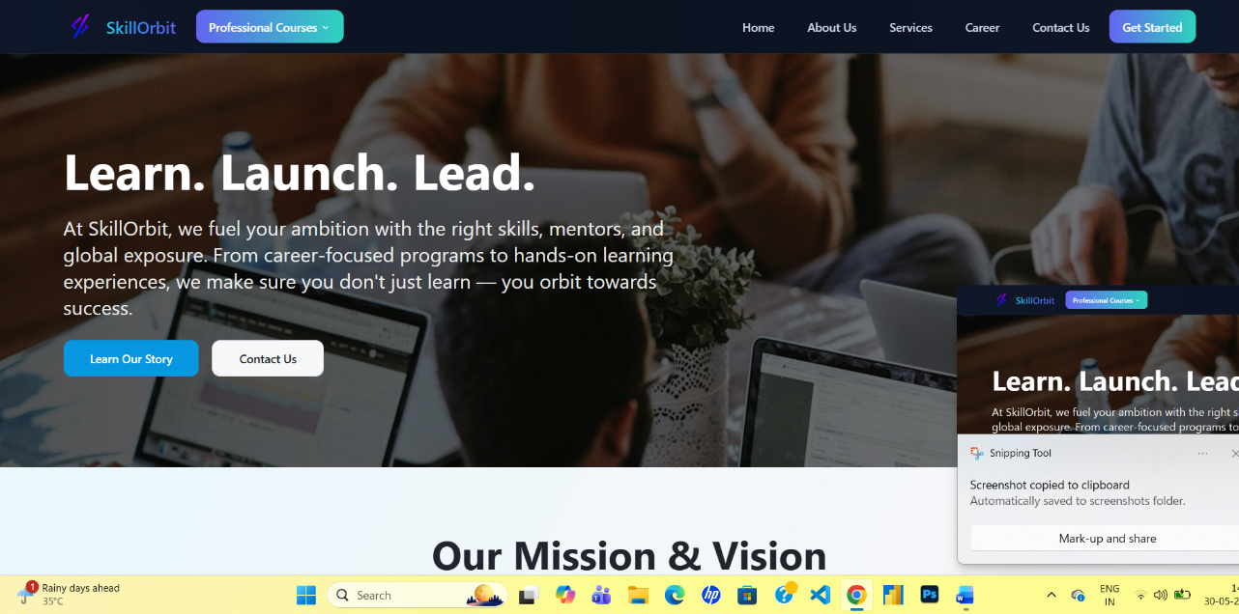

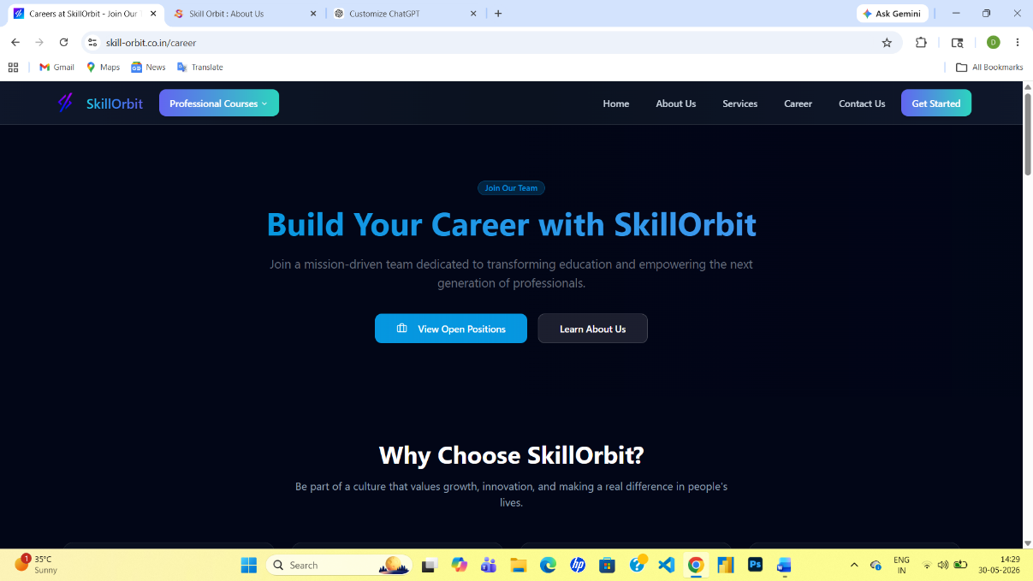

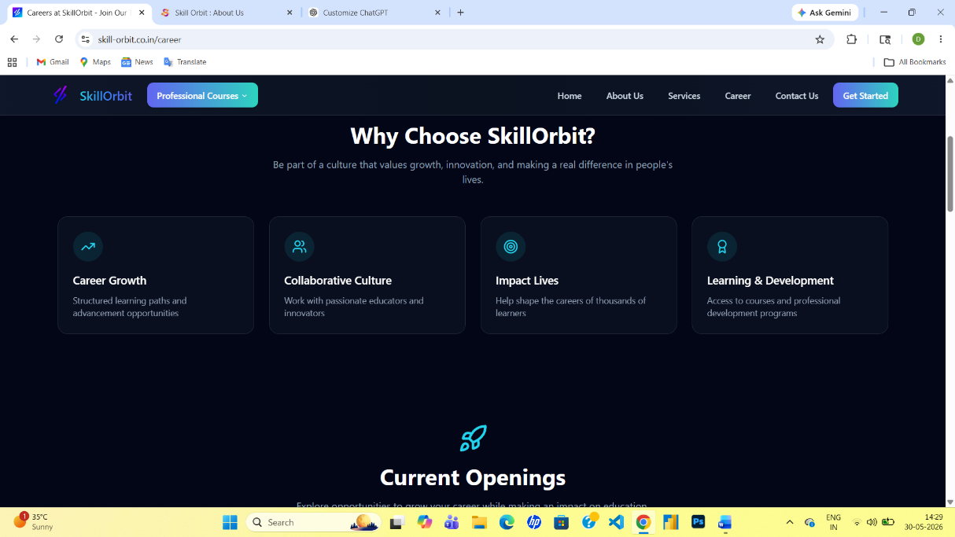

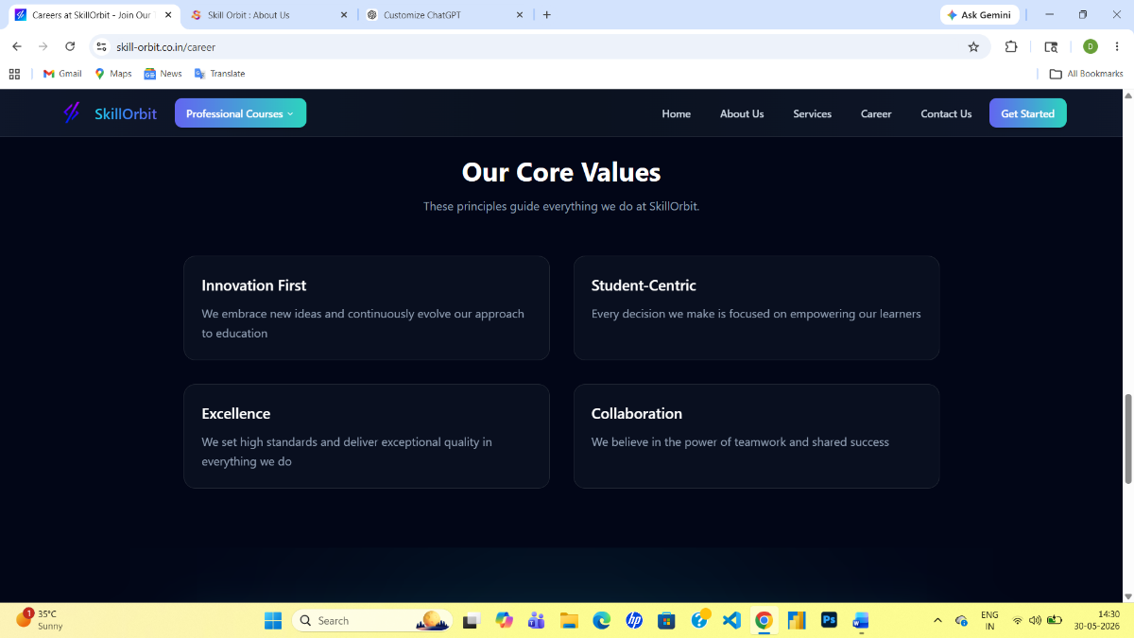

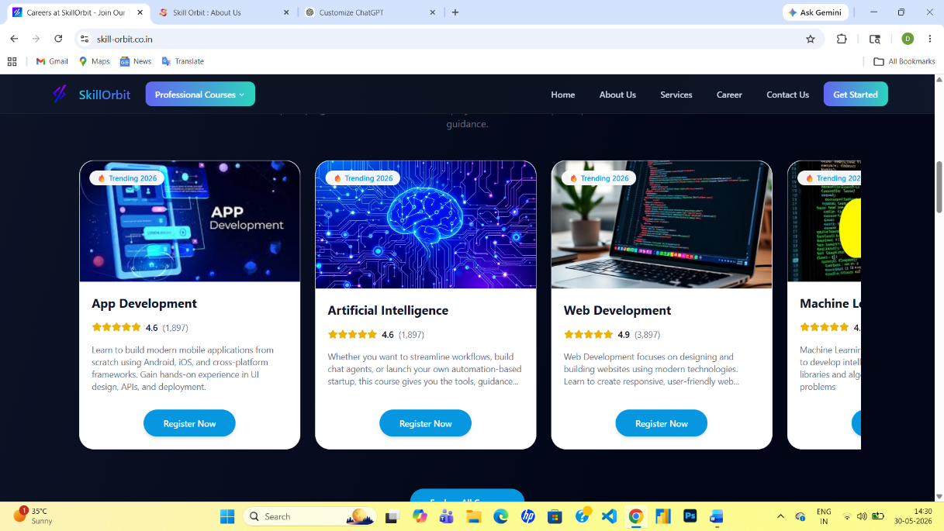
Course interface:

Login and signup section is compulsory:
